1. How does put() method of hashmap works in java?

A-> On hashing principal.

1. What are the requirements for the object to be used as key and value in hashmap?

A-> both key and value implements hashCode() and .equals() both.

1. What will happen if you try to store the a key which is already present in hashmap?

A-> It wont show compilation error but it returns value which is latest on the new key.

1. Can you store a null key inside hashmap in java?

A-> 1 null key is allowed.

1. Can you store a null value inside hashmap in java?

A-> numbers of null values is allowed.

1. How does hashmap handles collision in java?

A-> This collision means at same index more than 1 element. At same index number of elements can be attached and forms a link. It follows the linkedlist datastructure.

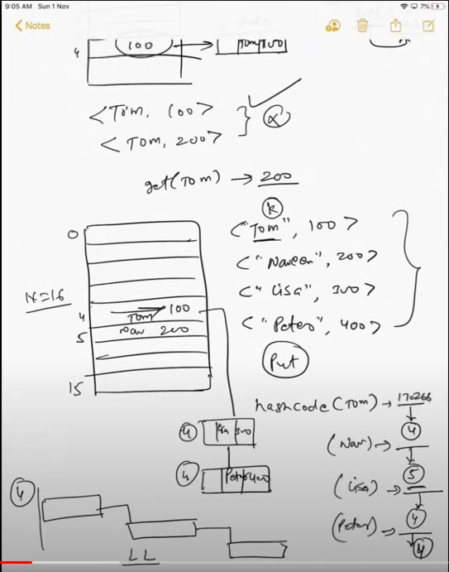

1. Which datastructure HashMap represents?

A-> First it creates 8 node (total is 16) in the form of LinkedList, once it is available, that 8 node is converted into binary tree.

1. Can u store a duplicate key in hashmap?

A-> No, it wont show compile error but override with latest value.

1. Can u store a duplicate value in hashmap?

A-> No, it wont show compile error but override with latest value.

1. Hashmap is thread safe in java?

A-> Not threadsafe (synchronised) by default. But we can make it thread safe by using synchronized hashmap or concurrent hashmap.

1. What will happen when you use hashmap in multithreaded java application?

A-> Chance of data get corrupted and might get the improper value while fetching.

1. What are the different ways to iterate the hashmap?

A-> by using keyset and iterator.

By using entryset and iterator.

By using entryset and enhanced for loop.

By using keyset and get method.

By using for-each with lambda.

1. How do you remove mapping while iterating over hashmap in java?

A-> use remove().

1. In which order mapping are stored in java?

A-> Random order coz hashmap doesn’t provide any ordering guarantee for keys, values and entry, When you iterate over a hashmap, u may get a different order every time u iterate over it.

1. Can u sort hashmap in java?

A-> Cant sort coz order is not fixed. To make it sorted convert map into linked hashmap.